UNITED STATES
SECURITIES AND EXCHANGE COMMISSION
Washington, D.C. 20549

FORM 8-K

CURRENT REPORT
Pursuant to Section 13 or 15(d) of the Securities Exchange Act of 1934
Date of Report (Date of earliest event reported): July 24, 2026

Lite Strategy, Inc.
(Exact name of Registrant as Specified in Its Charter)

Delaware |  |  | 001-41827 | 51-0407811
(State or other jurisdiction  of incorporation) |  |  | (Commission File Number) | (IRS Employer  Identification No.)
9920 Pacific Heights Blvd.,
Suite 150
San Diego, California |  |  |  | 92121
(Address of principal executive Offices) |  |  |  | (Zip Code)

Registrant’s telephone number, including area code: 858 369-7100

(Former name or former address, if changed since last report)

Check the appropriate box below if the Form 8-K filing is intended to simultaneously satisfy the filing obligation of the registrant under any of the following provisions:
☐Written communications pursuant to Rule 425 under the Securities Act (17 CFR 230.425)
☐Soliciting material pursuant to Rule 14a-12 under the Exchange Act (17 CFR 240.14a-12)
☐Pre-commencement communications pursuant to Rule 14d-2(b) under the Exchange Act (17 CFR 240.14d-2(b))
☐Pre-commencement communications pursuant to Rule 13e-4(c) under the Exchange Act (17 CFR 240.13e-4(c))
Securities registered pursuant to Section 12(b) of the Act:
Title of each class |  | Trading  Symbol(s) |  | Name of each exchange on which registered
Common Stock, $0.00000002 par value |  | LITS |  | The Nasdaq Stock Market LLC
Indicate by check mark whether the registrant is an emerging growth company as defined in Rule 405 of the Securities Act of 1933 (§ 230.405 of this chapter) or Rule 12b-2 of the Securities Exchange Act of 1934 (§ 240.12b-2 of this chapter).
Emerging growth company ☐
If an emerging growth company, indicate by check mark if the registrant has elected not to use the extended transition period for complying with any new or revised financial accounting standards provided pursuant to Section 13(a) of the Exchange Act. ☐

Item 7.01 Regulation FD Disclosure.
Lite Strategy, Inc. (the "Company") has prepared investor presentation materials with information about the Company, which it intends to use as part of investor presentations. A copy of such materials is attached as Exhibit 99.1 to this Current Report on Form 8-K.
The information in this Current Report on Form 8-K and in Exhibit 99.1 attached hereto is being furnished, but shall not be deemed “filed” for purposes of Section 18 of the Securities Exchange Act of 1934, as amended (“Exchange Act”), and is not incorporated by reference into any filing of the Company under the Securities Act of 1933, as amended, or the Exchange Act, whether made before or after the date hereof, regardless of any general incorporation language in such filing.

Item 9.01 Financial Statements and Exhibits.
Exhibit  No. |  | Description
99.1 |  | Investor Presentation dated July 2026
104 |  | Cover Page Interactive Data File – the cover page interactive data file does not appear in the Interactive Data File because its XBRL tags are embedded within the XBRL document.

SIGNATURES
Pursuant to the requirements of the Securities Exchange Act of 1934, the registrant has duly caused this report to be signed on its behalf by the undersigned hereunto duly authorized.
 |  |  | LITE STRATEGY, INC.
Date: | July 24, 2026 | By: | /s/ Justin J. File
 |  |  | Chief Executive Officer, Chief Financial Officer and Secretary

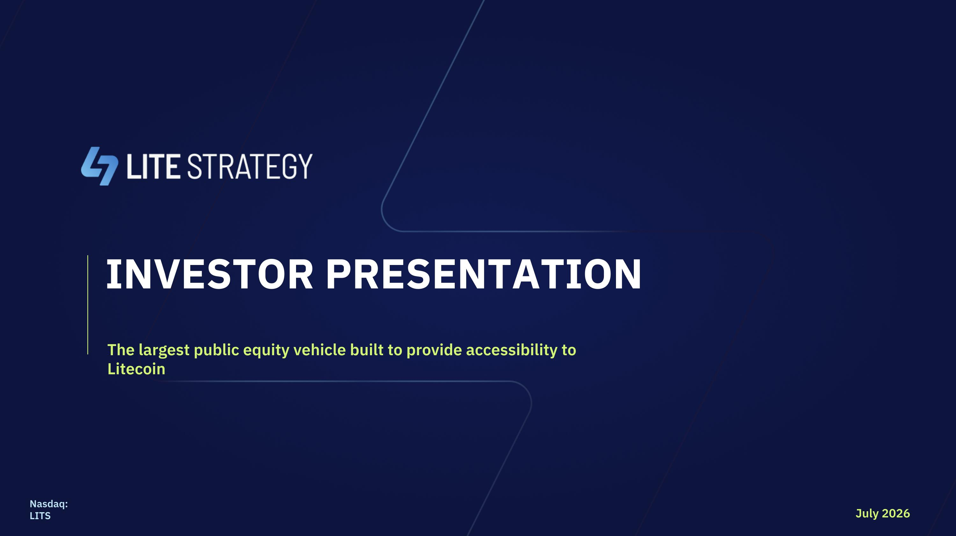
INVESTOR PRESENTATION The largest public equity vehicle built to provide accessibility to Litecoin July 2026 Nasdaq: LITS

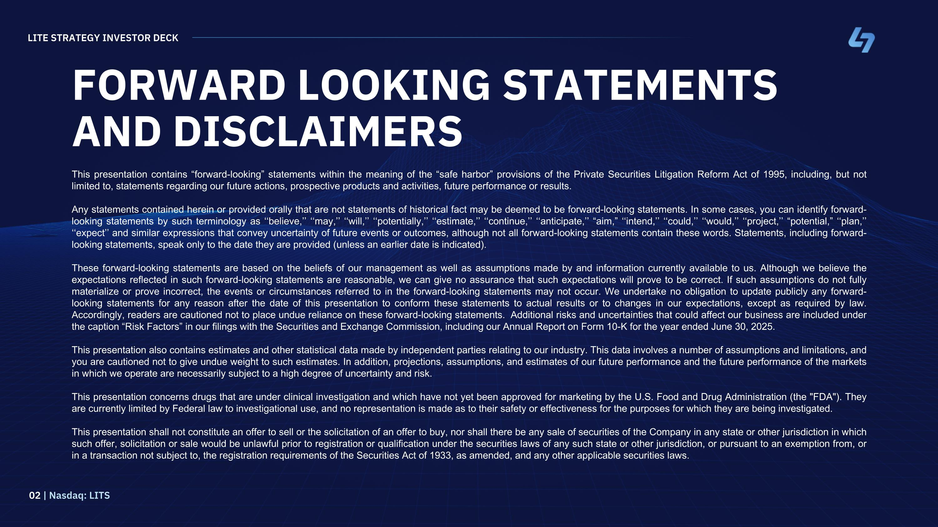
FORWARD LOOKING STATEMENTS AND DISCLAIMERS This presentation contains “forward-looking” statements within the meaning of the “safe harbor” provisions of the Private Securities Litigation Reform Act of 1995, including, but not limited to, statements regarding our future actions, prospective products and activities, future performance or results. Any statements contained herein or provided orally that are not statements of historical fact may be deemed to be forward-looking statements. In some cases, you can identify forward-looking statements by such terminology as ‘‘believe,’’ ‘‘may,’’ ‘‘will,’’ ‘‘potentially,’’ ‘‘estimate,’’ ‘‘continue,’’ ‘‘anticipate,’’ “aim,” ‘‘intend,’’ ‘‘could,’’ ‘‘would,’’ ‘‘project,’’ “potential,” ‘‘plan,’’ ‘‘expect’’ and similar expressions that convey uncertainty of future events or outcomes, although not all forward-looking statements contain these words. Statements, including forward-looking statements, speak only to the date they are provided (unless an earlier date is indicated). These forward-looking statements are based on the beliefs of our management as well as assumptions made by and information currently available to us. Although we believe the expectations reflected in such forward-looking statements are reasonable, we can give no assurance that such expectations will prove to be correct. If such assumptions do not fully materialize or prove incorrect, the events or circumstances referred to in the forward-looking statements may not occur. We undertake no obligation to update publicly any forward-looking statements for any reason after the date of this presentation to conform these statements to actual results or to changes in our expectations, except as required by law. Accordingly, readers are cautioned not to place undue reliance on these forward-looking statements. Additional risks and uncertainties that could affect our business are included under the caption “Risk Factors” in our filings with the Securities and Exchange Commission, including our Annual Report on Form 10-K for the year ended June 30, 2025. This presentation also contains estimates and other statistical data made by independent parties relating to our industry. This data involves a number of assumptions and limitations, and you are cautioned not to give undue weight to such estimates. In addition, projections, assumptions, and estimates of our future performance and the future performance of the markets in which we operate are necessarily subject to a high degree of uncertainty and risk. This presentation concerns drugs that are under clinical investigation and which have not yet been approved for marketing by the U.S. Food and Drug Administration (the "FDA"). They are currently limited by Federal law to investigational use, and no representation is made as to their safety or effectiveness for the purposes for which they are being investigated. This presentation shall not constitute an offer to sell or the solicitation of an offer to buy, nor shall there be any sale of securities of the Company in any state or other jurisdiction in which such offer, solicitation or sale would be unlawful prior to registration or qualification under the securities laws of any such state or other jurisdiction, or pursuant to an exemption from, or in a transaction not subject to, the registration requirements of the Securities Act of 1933, as amended, and any other applicable securities laws. LITE STRATEGY INVESTOR DECK 02 | Nasdaq: LITS

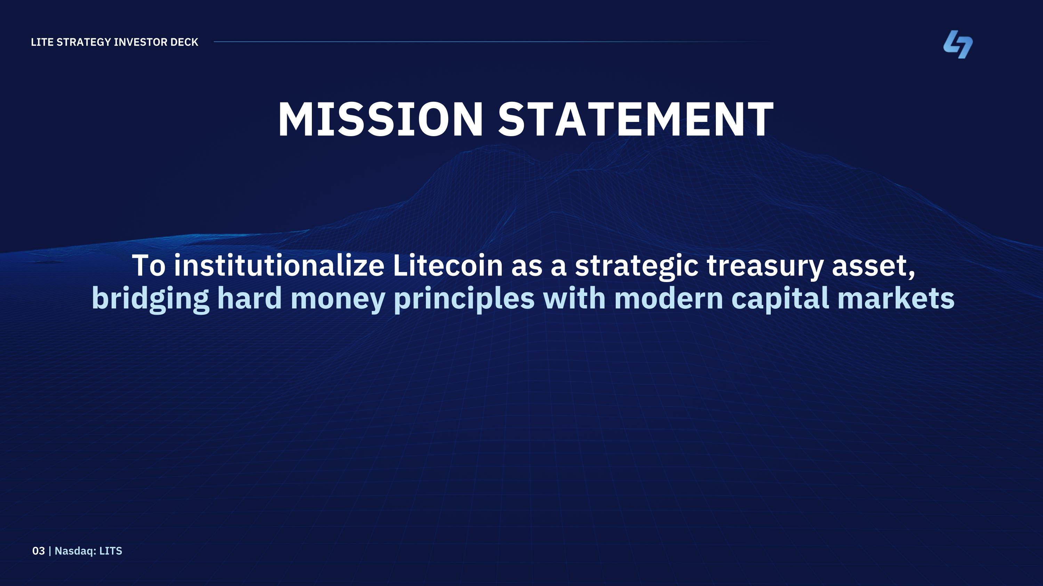
MISSION STATEMENT To institutionalize Litecoin as a strategic treasury asset, bridging hard money principles with modern capital markets LITE STRATEGY INVESTOR DECK 03 | Nasdaq: LITS

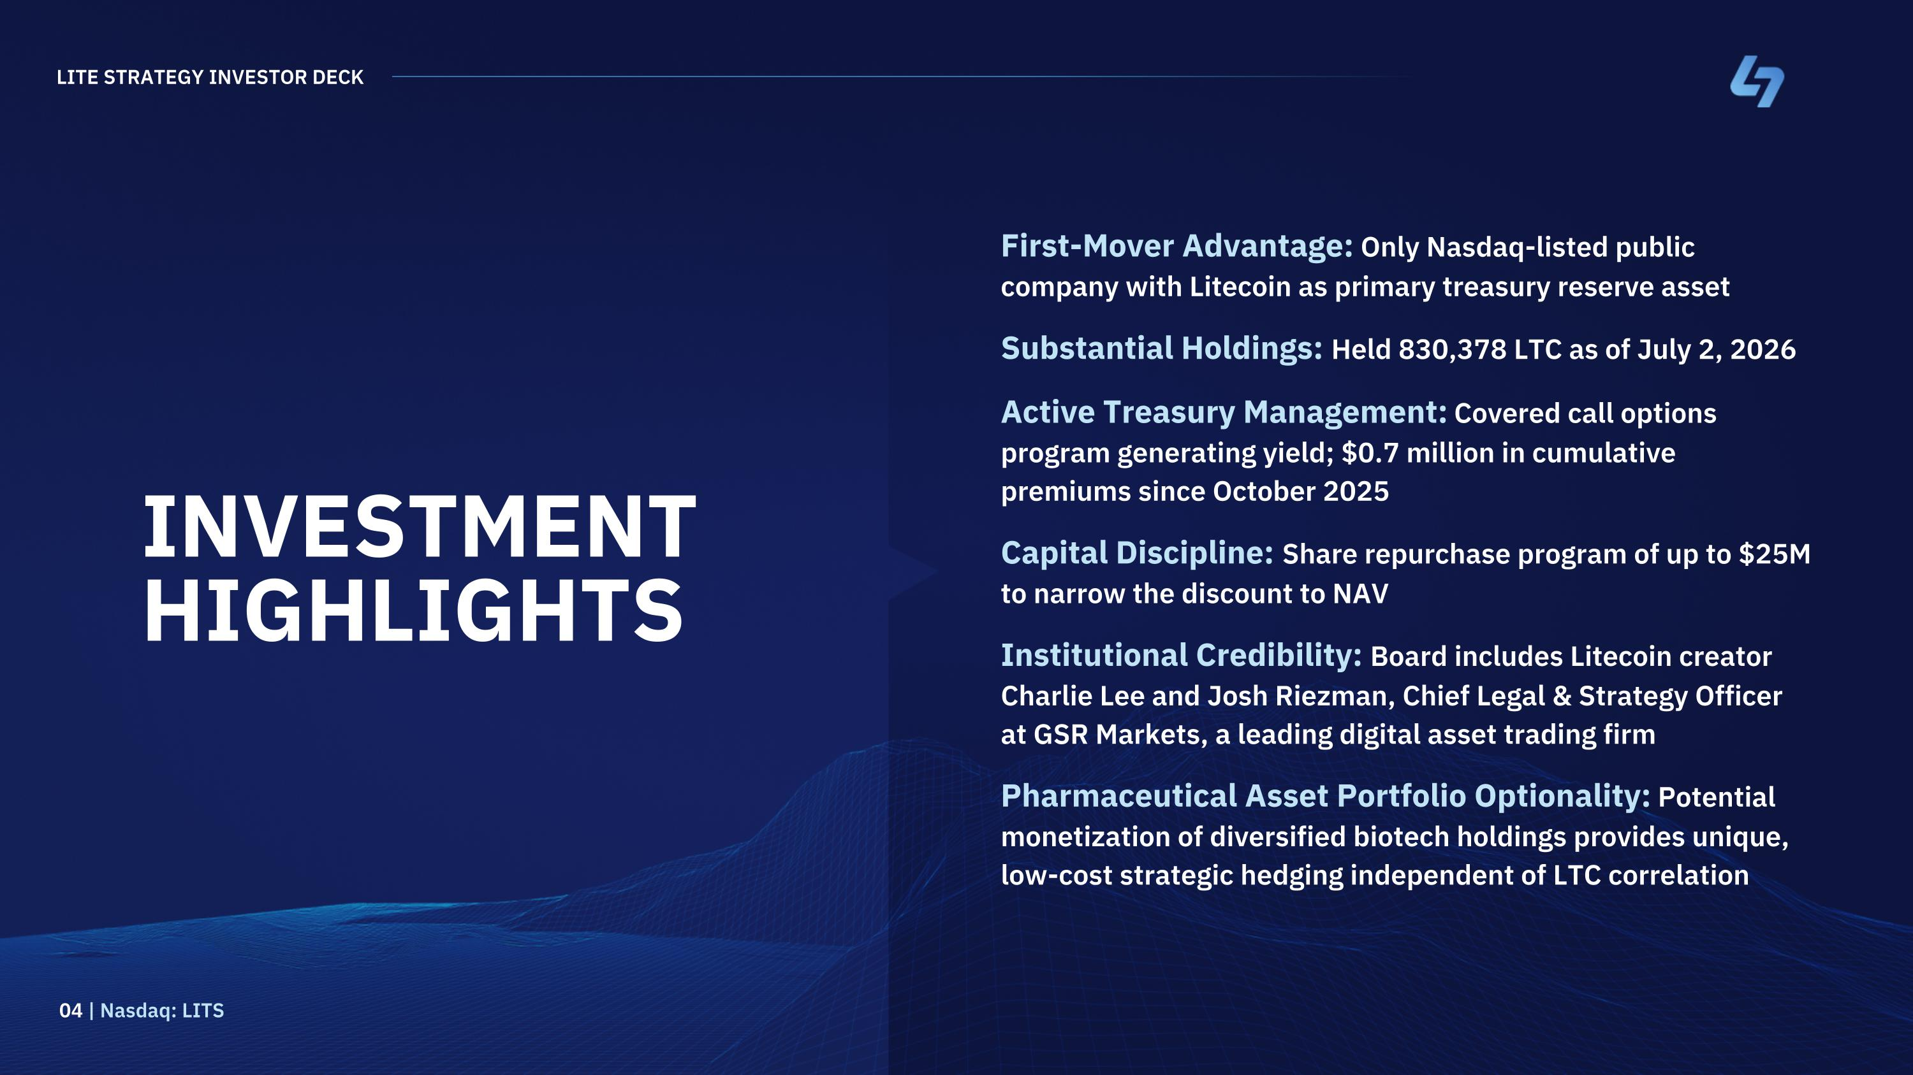
INVESTMENT HIGHLIGHTS First-Mover Advantage: Only Nasdaq-listed public company with Litecoin as primary treasury reserve asset Substantial Holdings: Held 830,378 LTC as of July 2, 2026 Active Treasury Management: Covered call options program generating yield; $0.7 million in cumulative premiums since October 2025 Capital Discipline: Share repurchase program of up to $25M to narrow the discount to NAV Institutional Credibility: Board includes Litecoin creator Charlie Lee and Josh Riezman, Chief Legal & Strategy Officer at GSR Markets, a leading digital asset trading firm Pharmaceutical Asset Portfolio Optionality: Potential monetization of diversified biotech holdings provides unique, low-cost strategic hedging independent of LTC correlation LITE STRATEGY INVESTOR DECK 04 | Nasdaq: LITS

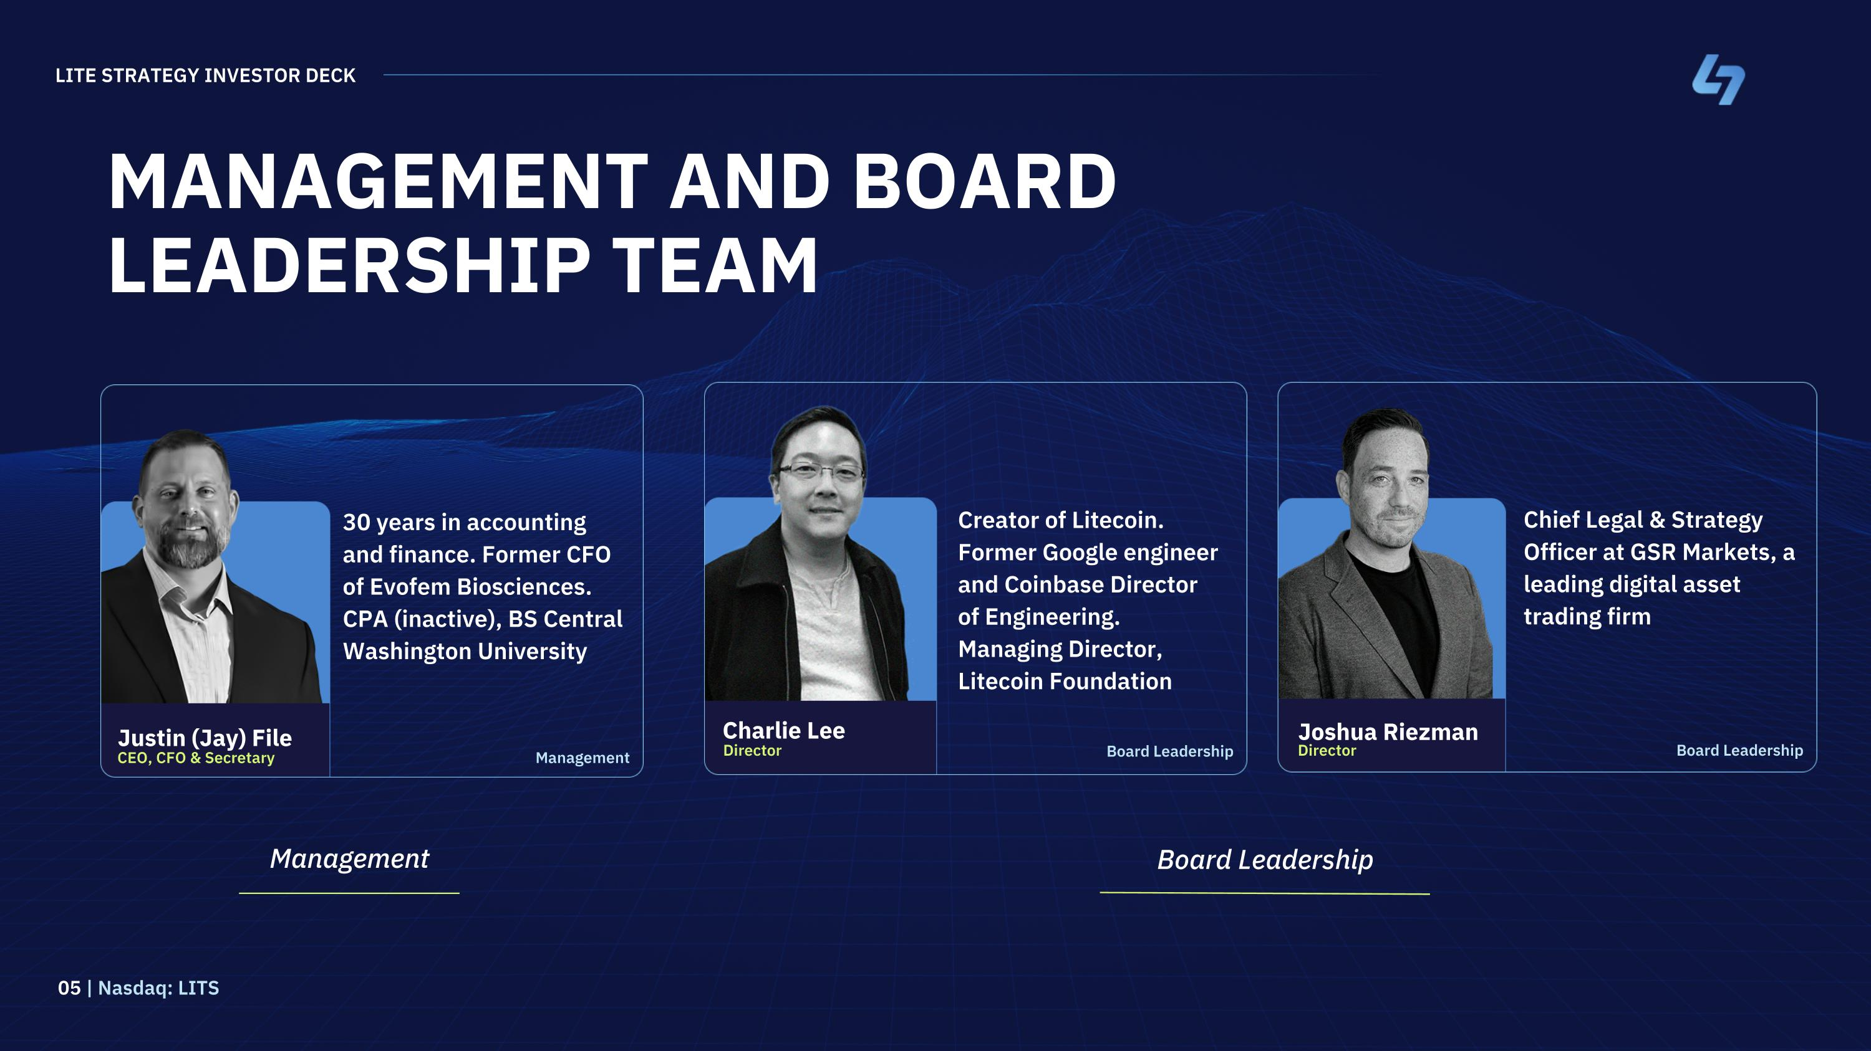
MANAGEMENT AND BOARD LEADERSHIP TEAM LITE STRATEGY INVESTOR DECK 05 | Nasdaq: LITS Creator of Litecoin. Former Google engineer and Coinbase Director of Engineering. Managing Director, Litecoin Foundation Chief Legal & Strategy Officer at GSR Markets, a leading digital asset trading firm 30 years in accounting and finance. Former CFO of Evofem Biosciences. CPA (inactive), BS Central Washington University Charlie Lee Director Joshua Riezman Director Justin (Jay) File CEO, CFO & Secretary Management Board Leadership Management Board Leadership Board Leadership

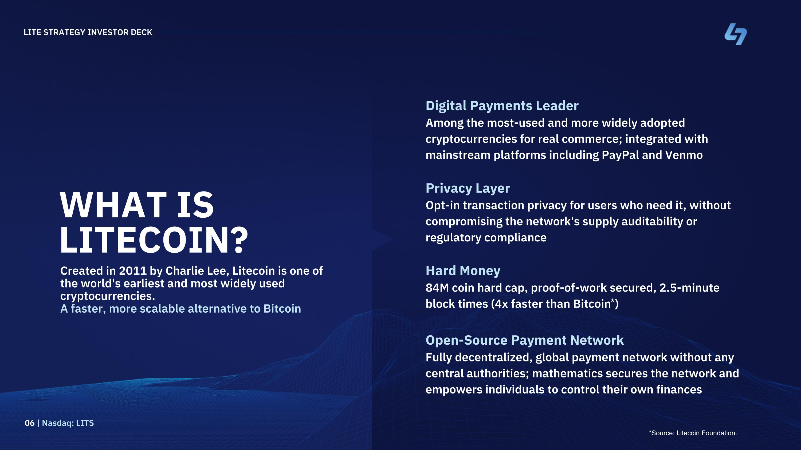
WHAT IS LITECOIN? Hard Money 84M coin hard cap, proof-of-work secured, 2.5-minute block times (4x faster than Bitcoin*) Created in 2011 by Charlie Lee, Litecoin is one of the world's earliest and most widely used cryptocurrencies. A faster, more scalable alternative to Bitcoin Digital Payments Leader Among the most-used and more widely adopted cryptocurrencies for real commerce; integrated with mainstream platforms including PayPal and Venmo Privacy Layer Opt-in transaction privacy for users who need it, without compromising the network's supply auditability or regulatory compliance LITE STRATEGY INVESTOR DECK 06 | Nasdaq: LITS Open-Source Payment Network Fully decentralized, global payment network without any central authorities; mathematics secures the network and empowers individuals to control their own finances *Source: Litecoin Foundation.

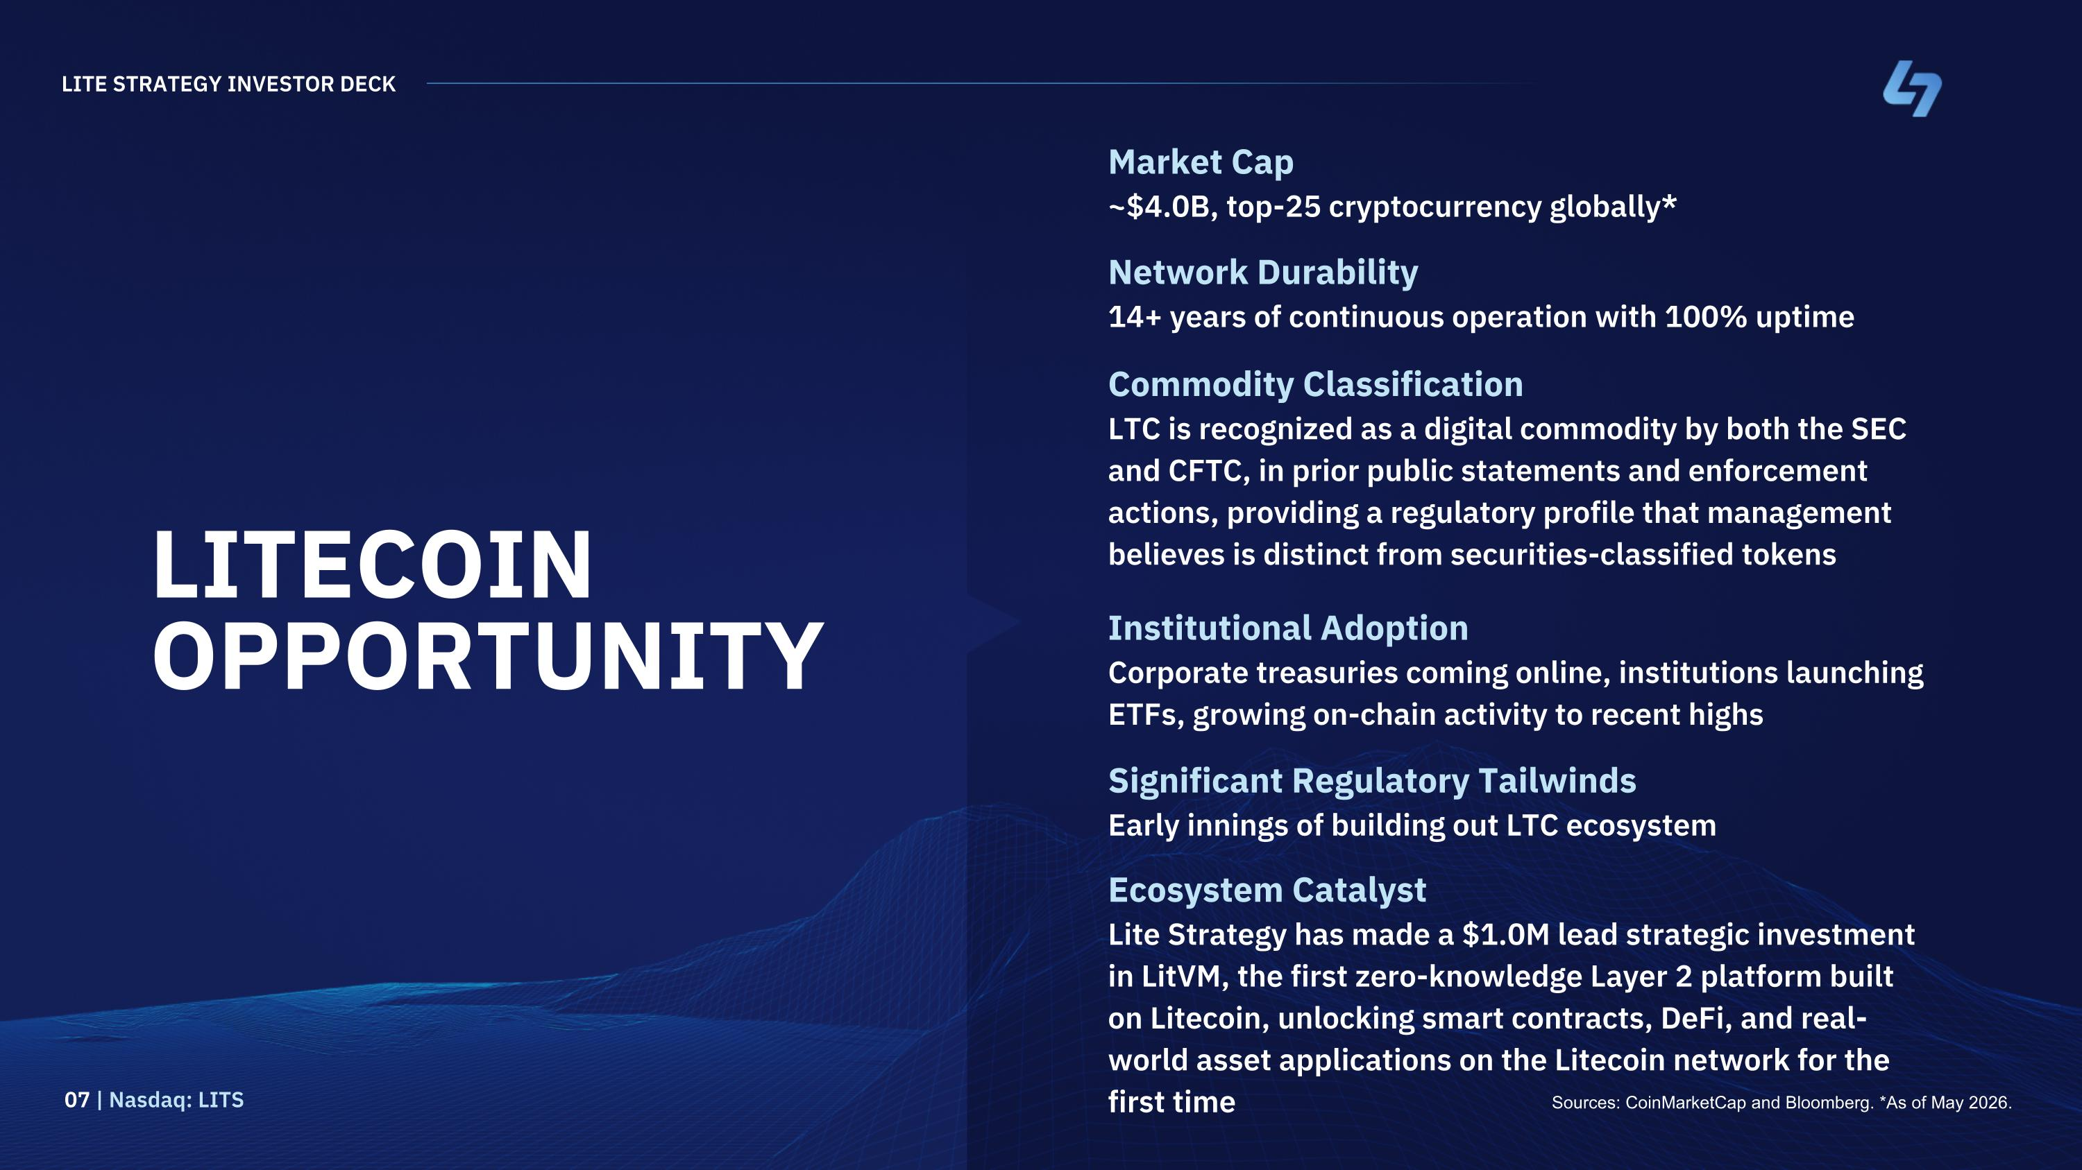
LITECOIN OPPORTUNITY Market Cap ~$4.0B, top-25 cryptocurrency globally* Institutional Adoption Corporate treasuries coming online, institutions launching ETFs, growing on-chain activity to recent highs Significant Regulatory Tailwinds Early innings of building out LTC ecosystem Ecosystem Catalyst Lite Strategy has made a $1.0M lead strategic investment in LitVM, the first zero-knowledge Layer 2 platform built on Litecoin, unlocking smart contracts, DeFi, and real-world asset applications on the Litecoin network for the first time Sources: CoinMarketCap and Bloomberg. *As of May 2026. LITE STRATEGY INVESTOR DECK 07 | Nasdaq: LITS Network Durability 14+ years of continuous operation with 100% uptime Commodity Classification LTC is recognized as a digital commodity by both the SEC and CFTC, in prior public statements and enforcement actions, providing a regulatory profile that management believes is distinct from securities-classified tokens

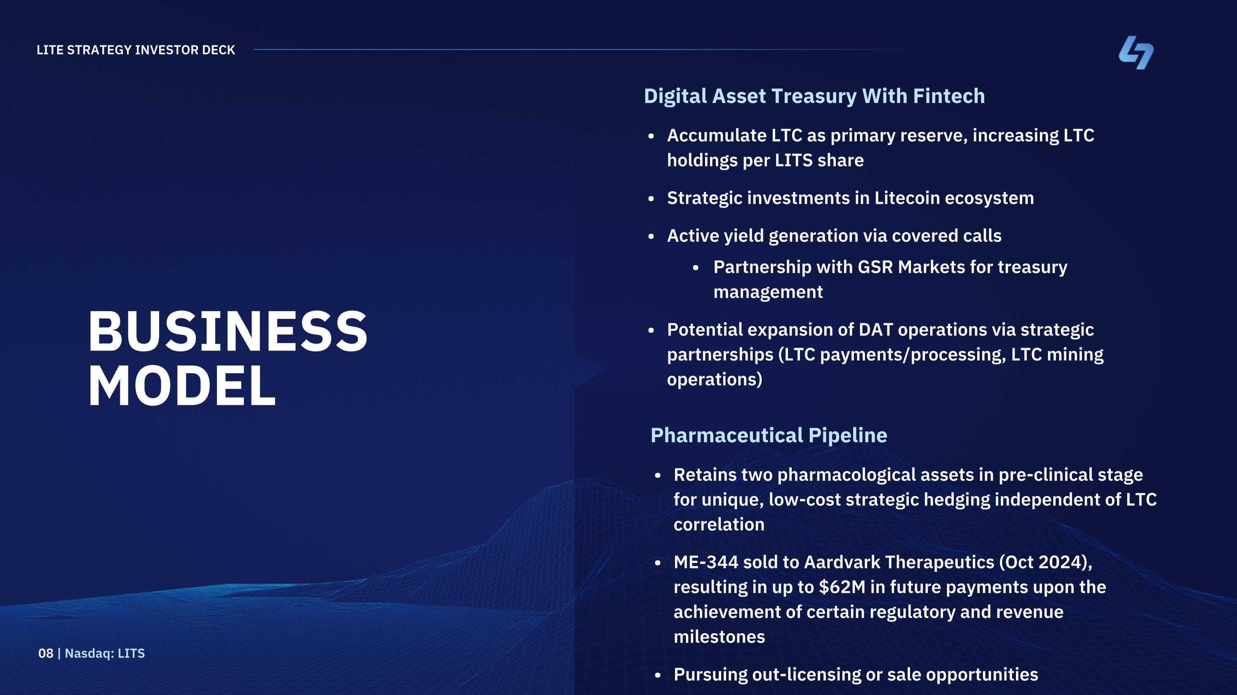
BUSINESS MODEL Digital Asset Treasury With Fintech Accumulate LTC as primary reserve, increasing LTC holdings per LITS share Strategic investments in Litecoin ecosystem Active yield generation via covered calls Partnership with GSR Markets for treasury management Potential expansion of DAT operations via strategic partnerships (LTC payments/processing, LTC mining operations) LITE STRATEGY INVESTOR DECK 08 | Nasdaq: LITS Pharmaceutical Pipeline Retains two pharmacological assets in pre-clinical stage for unique, low-cost strategic hedging independent of LTC correlation ME-344 sold to Aardvark Therapeutics (Oct 2024), resulting in up to $62M in future payments upon the achievement of certain regulatory and revenue milestones Pursuing out-licensing or sale opportunities

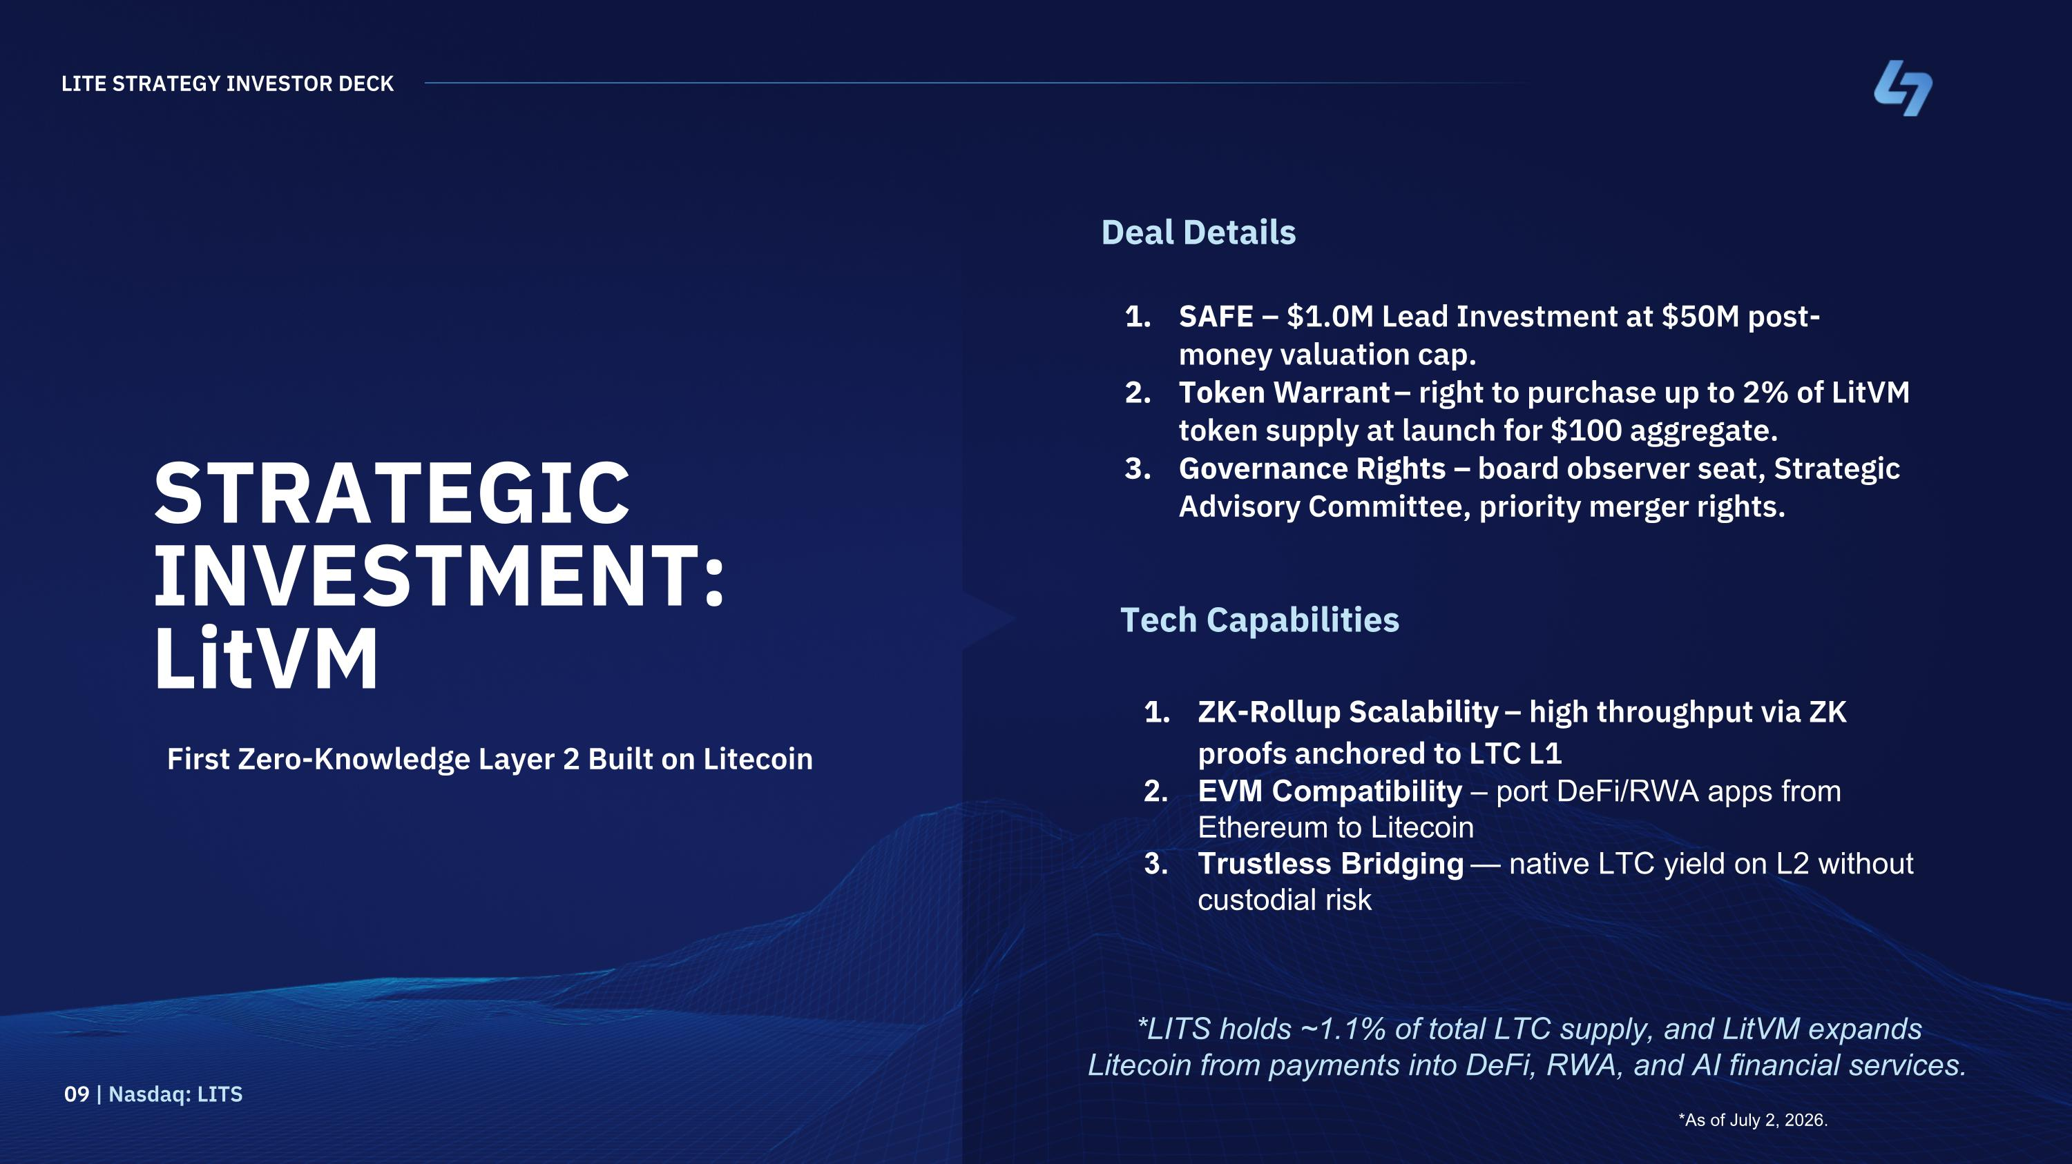
STRATEGIC INVESTMENT: LitVM First Zero-Knowledge Layer 2 Built on Litecoin Deal Details SAFE – $1.0M Lead Investment at $50M post-money valuation cap. Token Warrant – right to purchase up to 2% of LitVM token supply at launch for $100 aggregate. Governance Rights – board observer seat, Strategic Advisory Committee, priority merger rights. LITE STRATEGY INVESTOR DECK 09 | Nasdaq: LITS Tech Capabilities ZK-Rollup Scalability – high throughput via ZK proofs anchored to LTC L1 EVM Compatibility – port DeFi/RWA apps from Ethereum to Litecoin Trustless Bridging — native LTC yield on L2 without custodial risk *LITS holds ~1.1% of total LTC supply, and LitVM expands Litecoin from payments into DeFi, RWA, and AI financial services. *As of July 2, 2026.

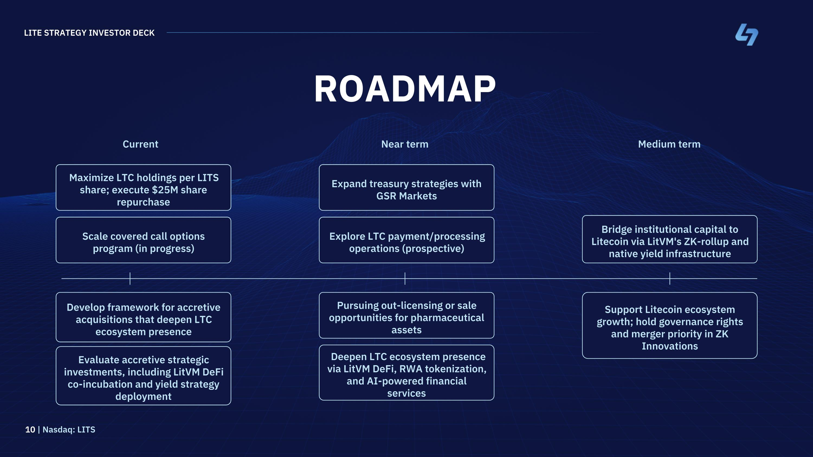
ROADMAP Maximize LTC holdings per LITS share; execute $25M share repurchase Scale covered call options program (in progress) Develop framework for accretive acquisitions that deepen LTC ecosystem presence Evaluate accretive strategic investments, including LitVM DeFi co-incubation and yield strategy deployment LITE STRATEGY INVESTOR DECK 10 | Nasdaq: LITS Expand treasury strategies with GSR Markets Explore LTC payment/processing operations (prospective) Pursuing out-licensing or sale opportunities for pharmaceutical assets Deepen LTC ecosystem presence via LitVM DeFi, RWA tokenization, and AI-powered financial services Bridge institutional capital to Litecoin via LitVM's ZK-rollup and native yield infrastructure Support Litecoin ecosystem growth; hold governance rights and merger priority in ZK Innovations Current Near term Medium term

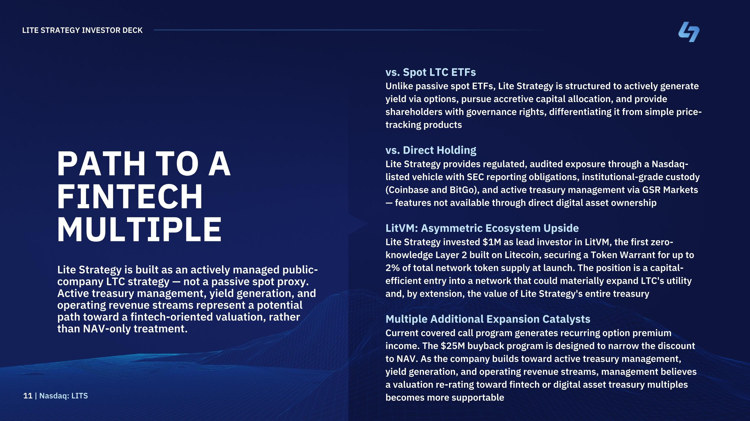
PATH TO A FINTECH MULTIPLE Lite Strategy is built as an actively managed public-company LTC strategy — not a passive spot proxy. Active treasury management, yield generation, and operating revenue streams represent a potential path toward a fintech-oriented valuation, rather than NAV-only treatment. vs. Spot LTC ETFs Unlike passive spot ETFs, Lite Strategy is structured to actively generate yield via options, pursue accretive capital allocation, and provide shareholders with governance rights, differentiating it from simple price-tracking products vs. Direct Holding Lite Strategy provides regulated, audited exposure through a Nasdaq-listed vehicle with SEC reporting obligations, institutional-grade custody (Coinbase and BitGo), and active treasury management via GSR Markets — features not available through direct digital asset ownership LitVM: Asymmetric Ecosystem Upside Lite Strategy invested $1M as lead investor in LitVM, the first zero-knowledge Layer 2 built on Litecoin, securing a Token Warrant for up to 2% of total network token supply at launch. The position is a capital-efficient entry into a network that could materially expand LTC's utility and, by extension, the value of Lite Strategy's entire treasury Multiple Additional Expansion Catalysts Current covered call program generates recurring option premium income. The $25M buyback program is designed to narrow the discount to NAV. As the company builds toward active treasury management, yield generation, and operating revenue streams, management believes a valuation re-rating toward fintech or digital asset treasury multiples becomes more supportable LITE STRATEGY INVESTOR DECK 11 | Nasdaq: LITS

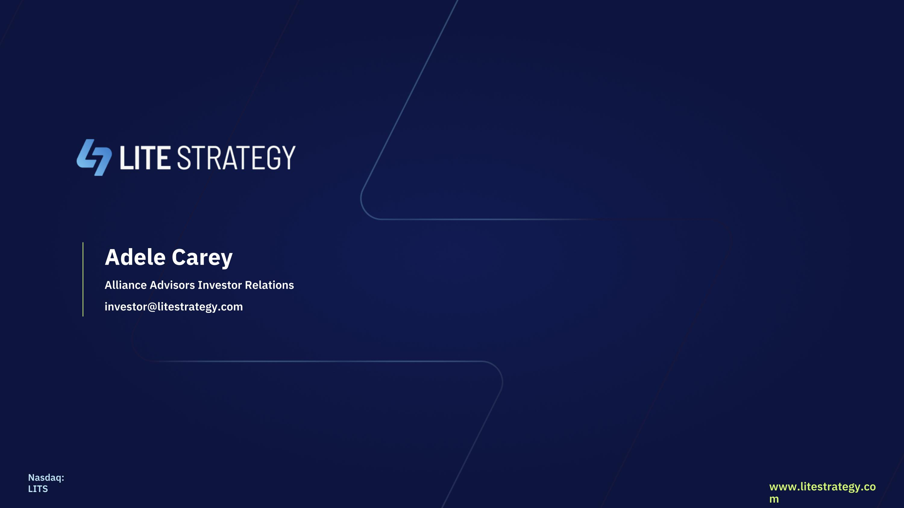
Adele Carey Alliance Advisors Investor Relations investor@litestrategy.com Nasdaq: LITS www.litestrategy.com

